# DIS 2.0 Factory Kit Guidance

## Overview

DIS 2.0 Factory Kit is a collection of sample scripts, tools and instructions to assist the factories that have adopted DIS 2.0 to complete their OA3.0 process in the production line.

## Working with Production Line Script

### Directory Structure

After extracting the zip package of DIS 2.0 Factory Kit, you will see a .zip file named OA30.zip in the extracted directory. Extract OA30.zip to a specific directory. Navigating the extracted directory, you will see the structure like the screen shot below:

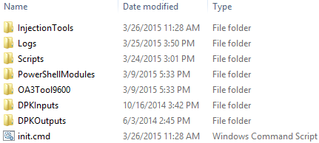

The following table describes each of the directory contents in more detail:

|  |  |  |
| --- | --- | --- |
| **Content Name** | **Content Type** | **Description** |
| InjectionTools | directory | The (suggested) sub directory to place and hold your DPK injection tool |
| Logs | directory | The sub directory for holding all of the production logs |
| Scripts | directory | The sub directory for holding the production line scripts |
| PowerShellModules | directory | The sub directory for holding the PowerShell modules to be used by the production line scripts |
| OA3Tool9600 | directory | The sub directory for holding the 9600 version of OA3Tool, with both x86 and amd64 edition included |
| DPKInputs | directory | The sub directory for holding the key files generated from OA3Tool / Assemble, or exported from DIS |
| DPKOutputs | directory | The sub directory for holding the key files generated from OA3Tool / Report, and to be saved back to DIS |
| init.cmd | file | The Windows command script to create some of the sub directories above in case of missing (optional) |

### Types of Sample Scripts

In the .\Scripts sub directory, you will see 4 PowerShell scripts in it, each works in OA3Tool’s server-based / file-based mode with 1 of the 2 approaches of unit serial number processing:

* Reading serial number from the BIOS of each unit;
* Reading serial number from the screen input during the boot time of each unit (with a keyboard or barcode reader connected).

### Configuring OA3Tool

### Modifying Sample Scripts to Integrate Injection Tool

### Interacting with DIS 2.0

## Building Boot Image

## Working with Serial Number